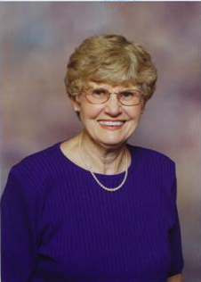

Lois Ann Wolfe Harrington – 2006

**Russell Philip and Margaret Lafferty Family**

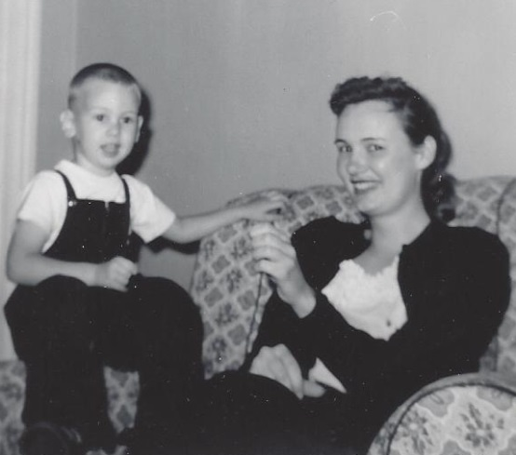

Dan Harrington & Margaret Lafferty - June 1957